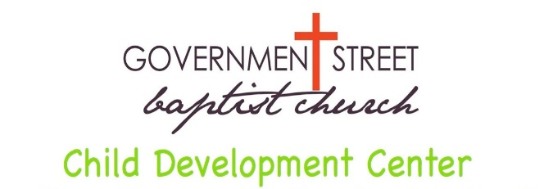
3401 Government Boulevard
Mobile, Alabama 36693-4301
(251) 660-7444
fax (251) 660-1097

Recurring Payment Authorization Form
You may now schedule your payments to be automatically deducted from your bank account or charged to your Visa, MasterCard, American Express or Discover Card. Each child must have a secondary form of payment (credit or debit card) on file.
If you do not wish to set up recurring payments, you will still be able to pay by cash or check. However, these payments will be due in advance of your child staying for childcare on each Monday morning. If your payment is not received by close of business on Wednesday, a late fee of $10 will be added and the credit/debit card on file will be charged on Thursday morning. There will be no exceptions to this policy.
Parent Name___________________________________________________________________
Address_______________________________________________________________________
City_________________________ State____________________ Zip Code_________________
Home #_____________________Work #___________________Cell #_____________________
Email Address__________________________________________________________________
Child’s First & Last Name(s)_______________________________________________________
___________________________________________________________________
I hereby authorize Government Street Baptist Child Development Center to charge my debit or credit card or automatically deduct from my checking or savings account indicated below. The weekly dollar amount showing due for each child will be deducted from or charged to the account indicated below on Monday of each week. This is for services rendered and is nonrefundable. You may indicate if you wish this payment to be deducted monthly or bi-weekly.
Checking / Savings Account Debit / Credit Card
Visa MasterCard
Amex Discover
Cardholder Name _______________________
Account Number ________________________
Exp. Date ______________________
CID (3 digit # on back of card) _____________
(There will be a $3 convenience fee per transaction)
Checking Savings
Name on Acct ________________________
Bank Name ________________________
Account Number _______________________
Bank Routing # _______________________
Bank City/State _______________________

I choose to pay my weekly fees by cash or check in advance of my child’s attendance each
Monday or my card on file will be charged on Thursday of that same week.

This authorization is to remain in full force and effect until Government Street Baptist Child Development Center has received written notification signed by me of its termination in such manner as to afford Government Street Baptist Child Development Center and Financial Institution a reasonable opportunity to act on it.
Signature___________________________________________________Date_______________

