Greetings CDC Families & Staff,

Since the last letter I posted the Governor has issued stay at home orders for the state of Alabama that extend to the end of April. Originally the order was on non-essential businesses closing til April 17. It seems each time I post a letter we have to extend this date, however I hope that doesn’t last long. While I still cannot give you a definitive answer as to when we will reopen, I pray we are getting closer to that date. God is in control and none of this surprises Him. We here at Government Street are just working hard to prepare for your return and we hope that we don’t have to miss summer together.
We are preparing classrooms and bulletin boards, etc as if you are returning very soon but we are also preparing for summer and next school year. Within the next couple of weeks, we will have registration forms available for you to fill out and return to reserve your child’s spot for the 2020-2021 school year. Stay tuned for more information to come on this.
I have added a tab on our website called UPDATES, so if you are not getting Facebook or email updates this will be another option. Also in today’s video on Facebook, you will see me doing a craft that the children would have done for Easter if they were here as part of their curriculum. I have posted this craft on our website for you as well under the UPDATES section. Please go to www.governmentstreetcdc.org
Please join us this Sunday at 9:30 AM for our drive-in Easter service followed by a drive-thru Easter egg hunt for the children. They will be able to hunt eggs from the safety of your car and receive a goody bag at the end. We would love to be able to wave at you through the window and say Happy Easter.
I am also proud to inform you that the sprinkler system is officially being put in while we are closed so we will be completely up to code by the time you return. This is very exciting.
We/I hope this letter finds all of you doing well and looking for ways to remain positive in an unsure time. There is always something that we can say “WOW GOD” about. Take time to do things you normally wouldn’t do. Play a game, read a book, put together a puzzle or do a craft, go for a walk, call a friend or have a ZOOM meeting with your whole family or friends you haven’t seen in a while. Trust me, you will receive a blessing and have a whole new outlook. As always, if you need anything or have any questions, please do not hesitate to reach out to us. We love you and we miss you and May God Bless You!!!
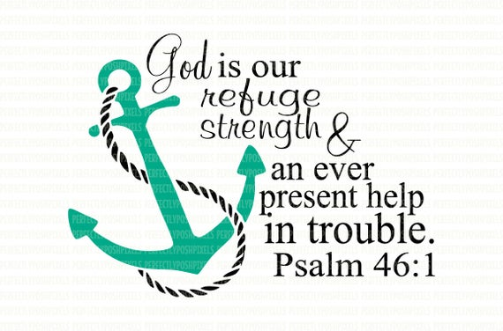
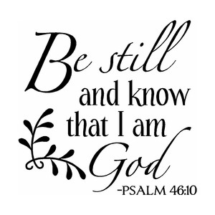
Much love,
Deborah Eddie
CDC Director
Deboraheddie@gsbc.onmicrosoft.com

