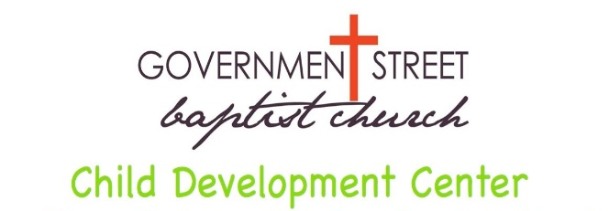
3401 Government Boulevard
Mobile, Alabama 36693-4301
(251) 660-7444
CDC Summer Camp
fax (251) 660-1097

Recurring Payment Authorization Form 2022
For your convenience you may now schedule your payments to be automatically deducted from your bank account or charged to your Visa, MasterCard, American Express or Discover Card through Headmaster Online. Once registered, you will receive your log-in information through email. In addition, each camper must have a secondary form of payment (credit/debit card or bank account) on file.
If you do not wish to set up recurring payments, you will still be able to pay by cash or check. However, these payments will be due in advance of your camper staying for summer camp on each Monday morning. If your payment is not received by close of business on Thursday, then the credit/debit card or bank account on file will be charged on Friday morning of the week services were rendered. There will be no exceptions to this policy.
Parent Name___________________________________________________________________
Address_______________________________________________________________________
City_________________________ State____________________ Zip Code_________________
Home #_____________________Work #___________________Cell #_____________________
Email Address__________________________________________________________________
Child’s First & Last Name(s)_______________________________________________________
___________________________________________________________________
I choose to pay my weekly fees in advance on Headmaster Online or set up recurring weekly payments through Headmaster Online. I understand that if these payments do not come through then the weekly dollar amount showing due for each camper will be deducted from or charged to the account indicated below on Friday of the week services were rendered.
I choose to pay my weekly fees by cash, check, or credit card in advance of my child’s attendance each Monday or my card on file will be charged on Friday of the week services were rendered with a $10 late fee added. This is for services rendered and is nonrefundable.

Checking / Savings Account Debit / Credit Card
Visa MasterCard
Amex Discover
Cardholder Name _______________________
Account Number ________________________
Exp. Date ______________________
CID (3 digit # on back of card) _____________
(There will be a $3 convenience fee per transaction)
Checking Savings
Name on Acct ________________________
Bank Name ________________________
Account Number _______________________
Bank Routing # _______________________
Bank City/State _______________________

This authorization is to remain in full force and effect until Government Street Baptist Child Development Center has received written notification signed by me of its termination in such manner as to afford Government Street Baptist Child Development Center and Financial Institution a reasonable opportunity to act on it.
Signature___________________________________________________Date_______________

